**SHRI G.S. INSTITUTE OF TECHNOLOGY & SCIENCE**

(AN AUTONOMOUS INSTITUTE, ESTABLISHED IN 1952)

**LABORATORY JOURNAL**

**ELECTRONICS DEVICES (EC-25016)**

**B. E. SECOND YEAR**

**DEPARTMENT OF ELECTRONICS & TELECOMMUNICATION**

NAME ______________________________________________________

ROLL NO ______________________________________________________

CLASS ______________________________________________________

BRANCH ______________________________________________________

SUBJECT ______________________________________________________

SEMESTER ______________________________________________________



NAME Anant Dev Srivastava

ROLL NO 0801ec191010

BRANCH **ELECTRONICS & TELECOMMUNICATION**

SUBJECT **ELECTRONICS DEVICES**

SEMESTER 3

***Certificate***

*This is to certify that Ms/ Mr.* Anant Dev Srivastava

*Roll No.* 0801ec191010  *studying in second Year_of this institute has completed practical course based on the syllabus and given a satisfactory account of it in the notebook containing a record of the laboratory work.*

*Signature*

*Date:*

*Grade: Professor in-charge*

SHRI G. S. Institute of Technology & Science, Indore

**Department of Electronics & Telecommunication Engineering**

**Bachelor of Engineering (Electronics & Telecommunication Engineering)**

**Vision and Mission of the Institute**

|  |
| --- |
| **VISION**  A front line institute in science and technology making significant contributions to human resource development envisaging dynamic needs of the society |
|  |

|  |
| --- |
| **MISSION**  To generate experts in science and technology relevant to society for its accelerated socio economic growth in professional and challenging environment imparting human values |

**Vision and Mission of the Department**

|  |
| --- |
| VISION  To be a leading Electronics and Telecommunication engineering department providing education at Graduate, Post-Graduate and research level fulfilling changing academic and industrial needs to create human resources in the field of modern Electronics and Telecommunication Engineering |

|  |
| --- |
| **MISSION**  Our efforts are dedicated in educating the students in the field of Electronics and Telecommunication Engineering to create competent professionals with high moral values, social ethics and for pursuing higher education and research |

**SHRI G. S. Institute of Technology & Science, Indore**

**Department of Electronics & Telecommunication Engineering**

**Bachelor of Engineering (Electronics & Telecommunication Engineering)**

The Department of Electronics and Telecommunication Engineering was established in 1972 and has been offering Bachelor of Engineering (B.E.) course since then. The department started M. E. (Electronics and Telecommunication Engineering) course in 2003 with emphasis on Telecommunication Technology in view of increased national teledensity, advances in the field of mobile communications and expansion of communication and computer networks in the country. The M.E. course of the department has been NBA accredited since January 2013 for 3 years. The department is a QIP Ph. D. center of MHRD, Govt. of India since 2012.

The department has well established laboratories in analog and digital electronics, communication systems, telecommunication systems and networking, digital signal processing, embedded systems, optical communications, microwave engineering and related fields. The department also has computing facilities with intranet and internet connectivity. The department participates in the distance education program of IIT Bombay as a remote center at the institute level. The department has actively participated in IMPACT project supported by World Bank, Swiss Development Corporation (SDC) and Department of Electronics (now known as Ministry of communication and information technology), Government of India, which was aimed at enhancing education facilities to create technical trained competent manpower. The department has participated in TEQIP Phase I and is also participating in TEQIP Phase II program of the institute. Faculty members and students are members of various professional societies and participate in their activities. The department has close interaction with Raja Ramanna Center for Advanced Technology (RRCAT), Indore in the field of joint conferences, seminars and student’s projects, etc. In the year 2013, renowned companies like Texas Instruments, Bangalore and BSNL have provided extensive on campus and off campus training to about 200 students of the department.

The department carries research in the areas of wireless channel modeling, channel coding, cross layer design issues, signal processing, routing protocols in computer networks, secure communication, sensor networks, micro strip antenna design using soft computing techniques, green wireless communication etc. Faculty members and research scholars regularly publish their work in international and national journals. Many students and faculty members of the department have received numerous awards and regularly participate in national and international conferences for paper presentations, expert talks, session chairs in India and abroad. Many alumni of the department have pursued M. Tech. and Ph. D. studies from various IITs, IISc and abroad after securing high percentile in GATE.

**SHRI G. S. Institute of Technology & Science, Indore**

**Department of Electronics & Telecommunication Engineering**

**Bachelor of Engineering (Electronics & Telecommunication Engineering)**

**Programme Educational Objectives (PEO)**

To create technically competent human resource capable of fulfilling dynamic socio-economic needs in the field of Electronics and Telecommunication Engineering

1. The graduates of Electronics & Telecommunication Engineering shall be competent Electronics and Telecommunication Engineers, with hardware & software component /subsystem selection capabilities, for system design, development, integration, operation, commission, maintenance and up gradation of the systems.
2. The graduates shall have competency to become successful professionals for accelerated socio-economic growth of the organization/ country.
3. The Electronics & Telecommunication Engineering graduates shall have high moral   
   values/ ethics to build an efficient team with appropriate soft skill capabilities.

**Programme Outcomes (PO)**

To develop core competency in various aspects of Electronics and Telecommunication systems and sub systems including their design, analysis, development and research in related areas with following program objectives:

1. Competency development in various mathematical fundamentals and their applications for solving engineering problems.
2. Design and analysis of telecommunication systems, signal processing and embedded systems.
3. Solving Electronics and telecommunication system problems using various modern hardware and software tools.
4. To develop team work and communication capabilities by way of minor and major   
    projects, seminar, technical report writing and their presentation.
5. The student shall have skill to apply the knowledge acquired in various subjects to solve a complex engineering problem
6. To guide students for national level competitive engineering exams.

**INDEX**

|  |  |  |  |  |  |
| --- | --- | --- | --- | --- | --- |
| S. No. | Experiment date | Name of the Experiment | Submission date | Remarks and Signature | Grade |
| 1 |  |  |  |  |  |
| 2 |  |  |  |  |  |
| 3 |  |  |  |  |  |
| 4 |  |  |  |  |  |
| 5 |  |  |  |  |  |
| 6 |  |  |  |  |  |
| 7 |  |  |  |  |  |
| 8 |  |  |  |  |  |
| 9 |  |  |  |  |  |
| 10 |  |  |  |  |  |
| 11 |  |  |  |  |  |
| 12 |  |  |  |  |  |
| 13 |  |  |  |  |  |
| 14 |  |  |  |  |  |
| 15 |  |  |  |  |  |

**INTRODUCTION**

Basic electronics is one of the first introductory laboratories in electronics engineering. It provides basic introduction to passive and active electronics components, their characteristics and applications of electronics devices in electronics circuits.

The practical experience gained by the student in the laboratory will be useful in designing more complex circuits, fault detection and testing of existing circuits etc.

The basic building blocks of basic electronics are rectifiers, regulators, clipper-clamper circuits, filters, oscillators, amplifies, feedback networks etc. They find applications in the wide range of areas including computers, television system, radar, communication, robotics, bio-medical instruments etc.

The success of experiments lies in its being performed in proper manner, taking proper reading and making meaning full conclusions/inferences from the experiments. The results will be in agreement with the theoretical prediction if the experiments are done in proper way. This also helps in getting hands on experience, confidence in making minor and major projects, developing faults diagnosis skill & reconfirming the fundamental principles of basic electronics.

**INSTRUCTIONS TO THE STUDENTS**

1. Students should come fully prepared to the laboratory for the experiment to be performed. He/she should read beforehand the objective of the experiment, list of test and measuring equipments required, theory of the experiment and observation table.
2. The student should read and observe all precautions to be taken during the experiment.
3. Return all the kits, wires, equipments, manuals etc. before leaving the laboratory.
4. Write the conclusions of the experiment mentioning the verification of the theoretically expected results with the observation. Mention the list of books, data sheet, complete Wed site address etc. at the end for further reference.
5. Submit your practical file on your next turn for checking along with the assignment related to the experiment and typical question and answer related to theory of experiment.
6. Be punctual and in well manners and handle equipments carefully for their proper usage, validity of readings and future use.

**PRECAUTIONS TO BE TAKEN IN THE LAB**

1. Make the connection properly.
2. Don’t exceed the maximum specified value of current/voltage for the given device.
3. Doubly check the pin connections with diagram for the polarity, correctness and firm binding of leads. Get it verified from team partner.
4. Set the knobs of the power supply to the minimum value by rotating the knobs anti-clockwise. Check the polarity of voltages.
5. Ensure that connections are firm, there are no loose wires or exposed joints and input or output leads do not short accidently.
6. Show the connections to the instructor/faculty members before applying input and switching on the power supply.

**LIST OF EXPERIMENTS**

1. Study a cathode-ray oscilloscope (CRO).
2. To determine the deflection sensitivity of CRO.
3. Study of V- I characteristics of Si diode.
4. To study the use of diodes in wave-shaping (clipper) circuits and in level-shifting (clamper) circuits
5. Study of Zener diode characteristics.
6. To study Zener diode as voltage regulator.
7. Study of different types of rectifiers.
8. Study of different types of filters.
9. Testing of transistor.
10. Study of transistor’s characteristics in CE (Common emitter) configuration.
11. To study BJT characteristics in CB (Common base) configuration.
12. To study the characteristics of BJT in CC (Common collector) configuration.
13. To study fixed bias circuit with and without emitter resistor.
14. Study of collector to base bias circuit.
15. Study of potential divider biasing circuit.

SHRI G.S. INSTITUTE OF TECHNOLOGY AND SCIENCE, INDORE-3

DEPARTMENT OF ELETRONICS & COMMUNICATION

ELECTRONICS DEVICES

Session: **______2020-21_______** Date_____________

Roll no: 0801ec191010 ______ Name of student__Anant_

Remarks: _____________

**Signature of Professor**

**EXPERIMENT-01**

**AIM:** - Study a cathode-ray oscilloscope (CRO).

**OBJECT**: **-** Determine amplitude and frequency of an unknown signal.

**APPARATUS REQUIRED:** -

1. Cathode-ray oscilloscope. Components: Si diode, 1kΩ resistor
2. Function generator.
3. CRO probes.

**THEORY**: - The cathode ray is a beam of electrons which are emitted by the heated cathode (negative electrode) and accelerated toward the fluorescent screen. The assembly of the cathode, intensity grid, focus grid, and accelerating anode (positive electrode) is called an electron gun. Its purpose is to generate the electron beam and control its intensity and focus. Between the electron gun and the fluorescent screen is two pair of metal plates - one oriented to provide horizontal deflection of the beam and one pair oriented to give vertical deflection to the beam. These plates are thus referred to as the horizontal and vertical deflection plates. The combination of these two deflections allows the beam to reach any portion of the fluorescent screen. Wherever the electron beam hits the screen, the phosphor is excited and light is emitted from that point. This conversion of electron energy into light allows us to write with points or lines of light on an otherwise darkened screen. In the most common use of the oscilloscope the signal to be studied is first amplified and then applied to the vertical (deflection) plates to deflect the beam vertically and at the same time a voltage that increases linearly with time is applied to the horizontal (deflection) plates thus causing the beam to be deflected horizontally at a uniform constant rate. The signal applied to the vertical plates is thus displayed on the screen as a function of time. The horizontal axis serves as a uniform time scale.

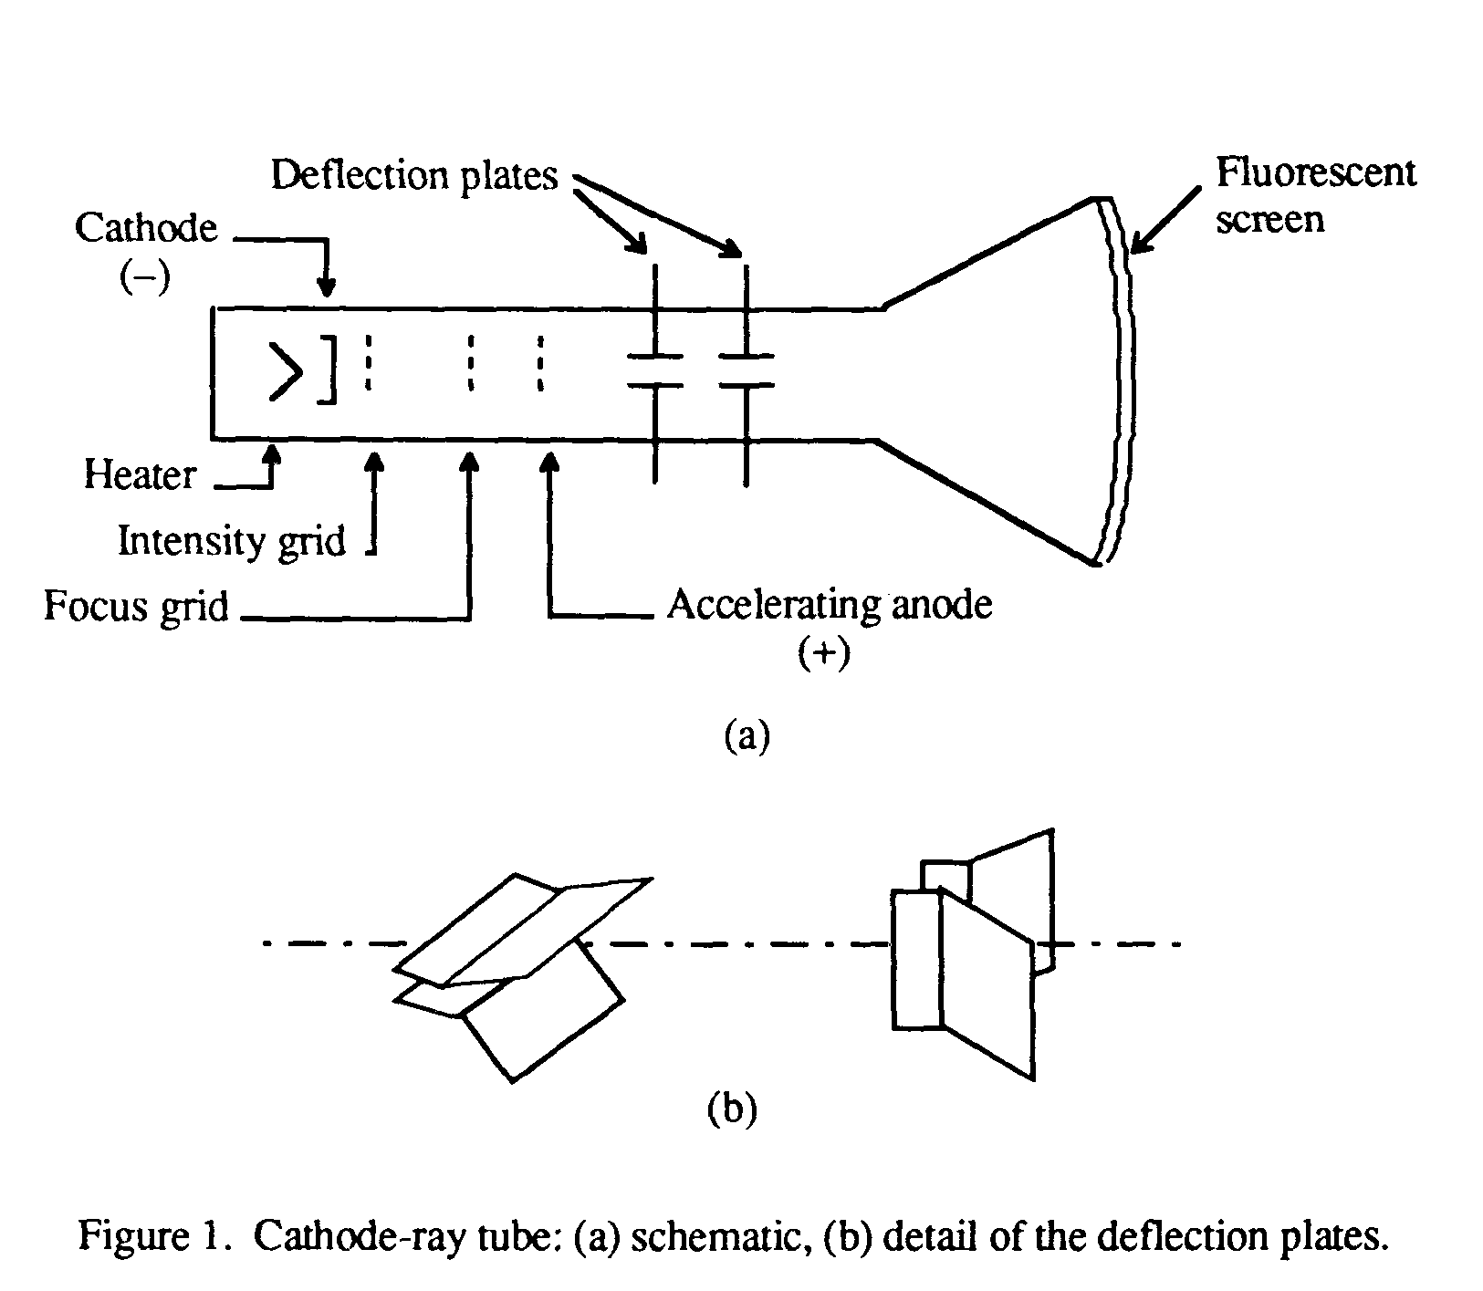



**Fig-2 Block Diagram of CRO**

**CRO OPERATION:**

A simplified block diagram of a typical oscilloscope is shown in Fig. 2. In general, the instrument is operated in the following manner. The signal to be displayed is amplified by the vertical amplifier and applied to the vertical deflection plates of the CRT. A portion of the signal in the vertical amplifier is applied to the sweep trigger as a triggering signal. The sweep trigger then generates a pulse coincident with a selected point in the cycle of the triggering signal. This pulse turns on the sweep generator, initiating the saw tooth wave form. The saw tooth wave is amplified by the horizontal amplifier and applied to the horizontal deflection plates. Usually, additional provisions signal are made for applying an external triggering signal or utilizing the 60 Hz line for triggering. Also the sweep generator may be bypassed and an external signal applied directly to the horizontal amplifier. Fig. 3 shows the front Panel of Cathode Ray Oscilloscope.

**FRONT PANEL CONTROLS:**

|  |  |  |
| --- | --- | --- |
| **1.** | **POWER** | Pushbuttons switch to turn scope ON/ OFF. LED indicates ‘POWER ON’ condition. |
| **2.** | **INTENS** | Intensity control to adjust brightness of CRT display. |
| **3.** | **TR** | Trace Rotation Pot. Screw driver adjustment for alignment of trace with reticule. |
| **4.** | **FOCUS** | Focus control to adjust sharpness of CRT display. |
| **5.** | **FREQUENCY** | Displays the frequency of triggered signal.  (7 Segment Display) |
| **6.** | **Y-POS.I** | Controls the vertical position of C.H.I trace. |
| **7.** | **Y-POS. II** | Controls vertical of CH.II trace. |
| **8.** | **INVERT (CH.I)** | Switch when pressed, inverts the polarity of C.H.I (PB switch) signal. In combination with ADD switch, used for algebraic addition or difference of two channels. |
| **9.** | **AC/DC/GD** | Input coupling switches for C.H.I. PB Switch  **AC:** Both switches in out position. Signal is capacitive coupled, DC is blocked.  **DC:** AC/DC switch pressed, GD switch in /out position. All components (AC & DC) of the signal are passed.  **GD:** GD switch pressed. AC/DC switch may be at any position. Signal is disconnected, I/P of vertical  Amplifier is grounded. |
| **10.** | **CH.I** | Signal input for CH.I, Input impedance 1MΩ **||** 25pF (BNC connector). |
| **11.** | **GROUND** | Separate Ground socket (4mm socket). |
| **12.** | **VOLTS/DIV.** | CH.I Input attenuator. Selects input sensitivity (Rotary Switch) in mV/div. or V/div. |
| **13.** | **CH.I/II-TRIG.I/II** | Switch in/out position: CH.I & internal trigger from PB Switch CH.I. Switch pressed: CH.II only & internal trigger from CH.I in DUAL & ADD mode switch selects internal trigger signal. |
| **14.** | **DUAL** | Switch in/ out position: Single Channel separately.  (PB Switch) only DUAL Switch pressed: CH.I &CH.II in CHOP mode. |
| **15.** | **ADD** | Only ADD switch pressed: Algebraic addition or  (PB Switch) difference of CH.I & CH.II, in combination with INVERT switches. |
| **16.** | **X-Y** | Switch when pressed, cuts off internal time base and (PB Switch). Selects X-Y operation.(X signal via CH.II). |
| **17.** | **X-POS** | Controls horizontal position of trace. |
| **18.** | **HOLD OFF** | Controls hold off time between sweeps in the ratio 1:10 approx. normal (cal) position: fully counter clockwise. |
| **19.** | **X-MAG**x**5** | Switch when pressed magnifies trace or signal 5 times in X-direction. On 0.5 s/div. range, this improves time base Speed to 100 ns/div. |
| **20.** | **DUAL**x**1-**x**5** | Switch when pressed displays the original trace as well as its 5 times magnified version, at a time. In DUAL channel mode it displays 4 traces. |
| **21.** | **TRIG.**  **AC-DC-HF-LF-~** | LED glows, if sweep is triggered.  **AC :** 10 Hz to 25MHz  **DC:** DC to 25MHz.  **HF:** 1.5 kHz to 50MHz.  **LF:** DC to 1k Hz.  **LINE~:** internal line triggering. |
| **22.** | **SEP.** (Lever Switch) | TV sync separator.  **OFF :** Normal operation  **TV: H:** Line or Horizontal Frequency.  **TV: V:** Frame or Vertical Frequency. |
| **23.** | **AT/NORM.** | Switch in out position: Automatic Triggering.  (Trace visible without signal.) Switch pressed: Normal triggering with level control.(Trace invisible without signal.) |
| **24.** | **LEVEL** | Adjusts trigger point of the signal from +ve peak to –ve peak, if AT/NORM PB switch (30) is pressed. |
| **25** | **+/-** | Selects the slope of trigger Signal.  **+:** rising edge.  **-:** falling edge. |
| **26.** | **ALT** | Switch when pressed, two signals of different frequency and shapes are triggered simultaneously. |
| **27.** | **EXT.** | Switch when selects external Triggering.  (Trigger signal via TRIG.INP.44)  Switch when released, select internal triggering. |
| **28.** | **TRIG.INP(BNC connector)** | Input for external Trigger signal. |
| **29.** | **1:1-1:20** | Switch when pressed I/P signal at Ext. BNC is attenuated 20 Times. |
| **30.** | **CAL 0.2V/2V**  (2mm socket) | Calibrator output sockets provided for probe  compensation Signal available at the sockets is flat top square wave, of Amplitude 0.2Vpp and 2Vpp,  Used for 100:1 probes compensation. frequency: 1K Hz approx. 0.2Vpp used for 10:1 probes compensation.2Vpp |
| **31.** | **CT**  (PB Switch & 4mm socket) | Switch when pressed converts the instrument from  Oscilloscope to Component tester mode. One test lead is connected to CT socket and the Second test Lead is connected to ground (10. or 16.) Socket. |

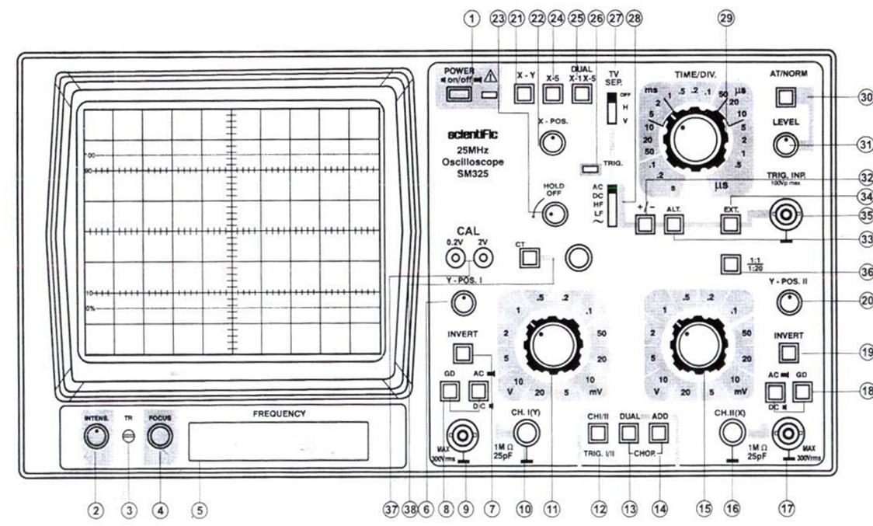

**OBSERVATIONS**: -

1. Amplitude:
2. Maximum Voltage =…2.54……. V
3. Peak to peak voltage =……5.08…. V
4. Frequency: …502.757….Hz.

**PRECAUTIONS:** -

**REPORT**: -

Q. 1 Why synchronization is need?

Q. 2 Explain Sweep generator internal circuit.

Q. 3 Write specification of CRO.

SHRI G.S. INSTITUTE OF TECHNOLOGY AND SCIENCE, INDORE-3

DEPARTMENT OF ELETRONICS & COMMUNICATION

ELECTRONICS DEVICES

Session: **______2020-21_______** Date_____________

Roll no: 0801ec191010 ___**_**__ Name of student Anant_ ___

Remarks: _____________

**Signature of professor**

**EXPERIMENT-02**

**AIM**: - To determine the deflection sensitivity of CRO.

**APPARATUS REQUIRED**:-

1. CRO with probes.
2. Function generator with probes.
3. AC Voltmeter.

**CIRCUIT DIAGRAM**:-

|  |
| --- |
|  |
| Fig. 1 Experimental set up for determination the deflection sensitivity of CRO. |
|  |
|  |
| Fig. 2 Sweep voltage generated by time base generator |

**THEORY**:-

In the cathode ray oscilloscope there are two pairs of plates. The plates in which electronic field is in the horizontal direction are called the X-plates and the other pair in which the electric–field is in the vertical directions are called Y-plate. Normally, a sweep voltage as shown in Fig. 2 is internally connected to the X - plate while the waveform to be seen is applied to the Y plate. If there were no signal on the X-plate, the spot would have moved up and down in straight line. The sweep signal on the plates provides a voltage proportional to time and therefore, the waveform of the signal on plate is displayed. The electron-beam from the electron gun striking the fluorescent screen follows the Y- signal waveform. Due to persistence of vision this path appears to be continuous. The synchronization of frequencies of the sweep & the Y-signal is necessary to obtain a stationary waveform.

The deflection sensitivity (D) of CRO at any frequency is given by the amplitude of deflection on the beam in the vertical direction for the Y-signal is necessary to obtain a stationary waveform.

The deflection sensitivity of CRO at any frequency is given by the amplitude of deflection on the beam in the vertical direction for the Y-signal divided by the corresponding magnitude of the signal.

Peak to peak deflection on CRO

Voltage,

Voltmeter reading

**PROCEDURE**:

1. Apply a voltage signal of constant frequency and variable magnitude to Y-plate of CRO.
2. Measure the length of vertical straight line obtained on the CRO - screen for corresponding magnitude. This will give you
3. Measure the same signal with AC voltmeter for two deflections. This will give you
4. Convert this in. Now calculate the sensitivity of the CRO using the given formula.
5. Repeat the procedure for difference frequencies.

**OBSERVATIONS**:

|  |  |  |  |  |
| --- | --- | --- | --- | --- |
| S. No | Frequency | Voltage applied of Y-plates (V) | Vertical displacement | Deflection sensitivity |
| 1 | 50 Hz |  |  |  |
| 2 | 1K |  |  |  |
| 3 | 10K |  |  |  |

**RESULT**: The deflection sensitivity of CRO is……….

**REPORT**:

1. What is synchronization & why it is necessary in CRO?
2. Give constructional detail of cathode ray tube.
3. Why blanking circuit is used?

SHRI G.S. INSTITUTE OF TECHNOLOGY AND SCIENCE, INDORE-3

DEPARTMENT OF ELETRONICS & COMMUNICATION

ELECTRONICS DEVICES

Session: **______2020-21_______** Date_____________

Roll no: 0801ec191010 ____**_**__ Name of student_Anant

Remarks: _____________

**Signature of Professor**

**EXPERIMENT-03**

**AIM:** - Study of V- I characteristics of diode.

**OBJECT**: **-** To plot V- I characteristics of a silicon p-n junction diode and to calculate its static and dynamic resistance.

**APPARATUS REQUIRED:** -

1. Experimental board
2. Components: Si diode, 1kΩ resistor
3. Variable DC power supply (0 – 20 V)
4. DC ammeter (range 0-10 mA)

DC ammeter (range 0-200 µA)

1. Voltmeter (0-1V forward, 0-20V reverse bias)
2. Connecting wires.

**CIRCUIT DIAGRAM**: -

|  |  |
| --- | --- |
|  | |
| (a) Forward bias | (b) Reverse bias |
| Fig. 1 Set up for the measurement of forward bias and reverse bias characteristics of a silicon p-n junction diode | |

**THEORY**: - A diode conducts in forward bias condition when its anode is at higher potential than its cathode. It ideally doesn’t conduct in reverse- bias (typical value of current for si-diode is in nano-ampere range in reverse –bias condition).

When the diode is forward biased, the barrier potential at the junction reduces. The majority carriers diffuse across the junction. This causes current to flow through the diode. In reverse-bias the barrier potential increases & almost no current flow through the diode. When positive terminal of the battery or power supply is connected to p-region of semiconductor diode (anode terminal) & negative terminal to n region, the junction is said to forward bias because it permits easy flow of current across the junction. When power supply connections are reversed, the diode is said to be reverse biased. A series resistance R=1k is connected in circuit so that excessive current doesn’t flow through the diode. A plot between voltage across diode & current gives forward characteristics of the diode.

At a given operating point we can determine the static resistance & dynamic resistance of the diode from its characteristic.

The static resistance is defined as the ratio of the dc voltage to dc current i.e.

The dynamic resistance is the ratio of a small change in voltage to a small change in current i.e.

**PROCEDURE**: -

1. Find the type- number of the diode connected in the experimental board.
2. Connect the voltmeter and multimeter of proper range & semiconductor diode as shown in Fig. 1 (a) so as to forward biased diode,
3. Vary the D.C. voltage from zero onward &record the current in the circuit for each set of value of voltage across the diode (don’t exceed the maximum specified value of current for the diode typically 10 mA).
4. Switch the supply. Connect the voltmeter and micro-ammeter of proper ranges for obtaining the reverse biased characteristics of diode as shown in Fig. 1 (b).

**OBSERVATIONS**:-

1. Type the number of diode =…………1N4001….……

**OBSERVATION TABLE**: -

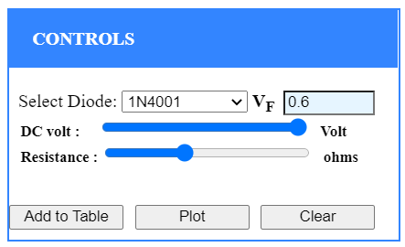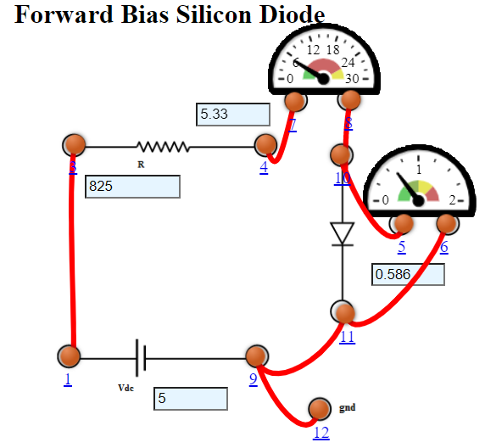

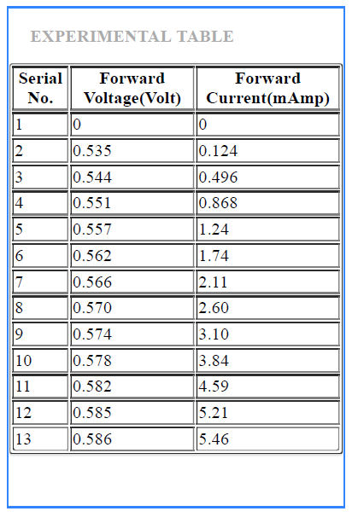

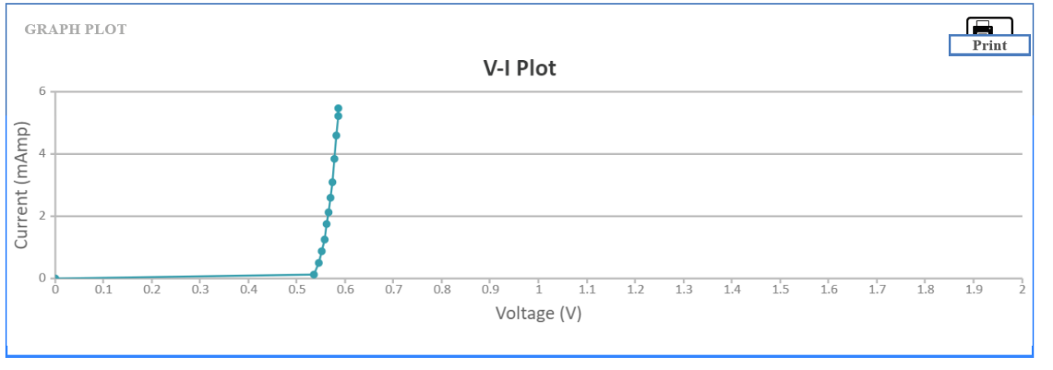

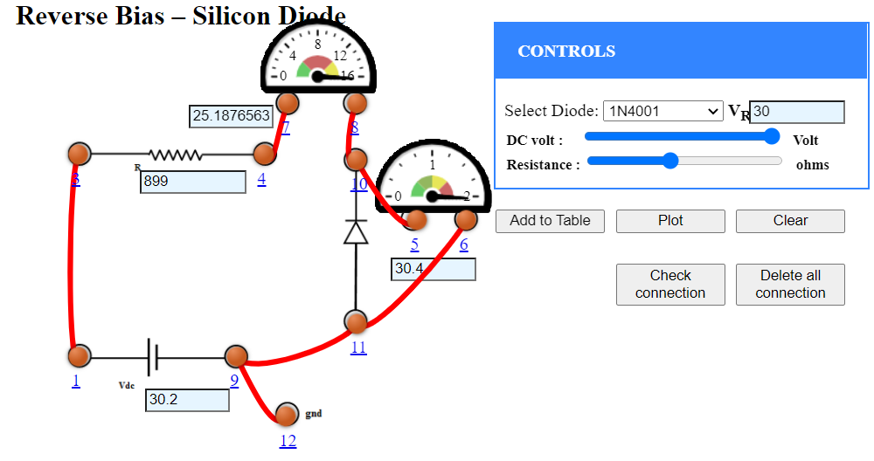

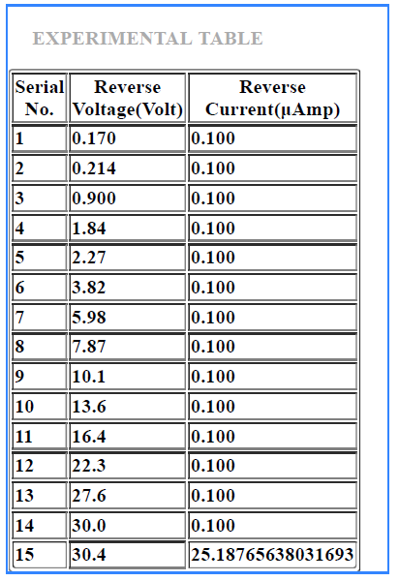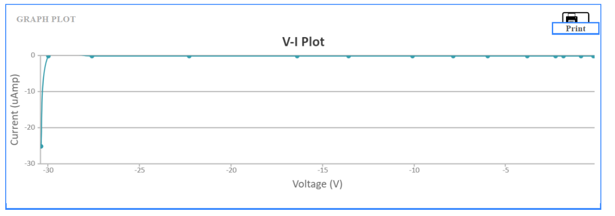

**CALCULATIONS**: -

1. Static Resistance:

2. Dynamic Resistance:

**RESULTS**: -

1. The V-I characteristics of diode is shown in graph.

2. Value of static and dynamic resistance of given diode is

**PRECAUTIONS:** -

1. Make the connection properly.
2. Don’t exceed the maximum specified value of current for the given diode.
3. Don’t exceed reverse voltage beyond maximum permissible reverse bias voltage.

**REPORT**: -

Q.1 Plot V-I characteristics of PN-junction diode on a suitable graph paper.

Q.2 Give complete specifications of the diode 1N4007.

Q.3 Explain how PN-junction formed.

SHRI G.S. INSTITUTE OF TECHNOLOGY AND SCIENCE, INDORE-3

DEPARTMENT OF ELETRONICS & COMMUNICATION

ELECTRONICS DEVICES

Session: **______2020-21_______** Date_____________

Roll no: 0801ec191010 __ Name of student Anant___

Remarks: _____________

**Signature of Professor**

**EXPERIMENT- 04**

**AIM**: - To study the use of diodes in wave-shaping (clipper) circuits and in level-shifting (clamper) circuits

**OBJECT**: -

• To understand the theory of operation of the clipping and clamping diode circuits.

• To design wave shapes that meet different circuits’ needs.

**APPARATUS REQUIRED**: -

1. Bread board
2. CRO
3. Function generator
4. Electronics components: Diodes, Resistors and Capacitors

**CIRCUIT DIAGRAM**: -

|  |  |
| --- | --- |
|  | |
| (a) clipper circuit | (b) clamper circuit |
| Fig. 1 Schematic of a clipper circuit and a clamper circuit | |

**THEORY**: - This experiment studies the applications of the diode in the clipping & clamping operations.

* + - 1. **Clipping circuits**:

The Fig 1 (a) shows a biased clipper, for the diode to turn on the input voltage must be greater than, when is greater than the diode acts like a closed switch (ideally) & the voltage across the output equals, this output stays at as long as the input voltage exceeds. When the input voltage is less than the diode opens and the circuit acts as a voltage divider, as usual, should be much greater than Rs in this way; most of input voltage appears across the output. The biased clipper removes all signals above the () level.

* + - 1. **Clampers circuits:**

Clampers are used primarily to shift the DC level. A typical clamper circuit is shown Fig 1 (b) is a positive clamper. During the negative half cycle of the input signal the diode is forward biased and acts like a short circuit. The capacitor charges to. Applying the KVL to the input side

The voltage across the resistor will be equal to the reference voltage.

During the positive half cycle of the input signal, the diode is reverse-biased and it acts as an open circuit. Hence  has no effect on. Apply KVL in the loop.

The output voltage is simply the input voltage shifted by.

The magnitude of  and C are chosen so that the time constantis large enough to ensure that the voltage across the capacitor does not discharge significantly during the diode's non-conducting interval.

**PROCEDURE**: -

**Clipping Circuit**:

1. Connect the circuit shown in Fig1 (a).
2. Ensure that the variable DC is at minimum and the source is at 10VP.P.
3. Observe and Sketch the input and output waveforms.
4. Increase the variable DC voltage to 4V, and notice to what voltage are the positive peaks chopped off, sketch the waveforms.

**Clamping Circuit**:

1. Connect the circuit shown in Fig 1 (b).
2. Ensure the variable DC is at minimum.
3. Set the sine wave generator frequency to 1 KHz and its output amplitude to 10VP.P.
4. Observe and sketch the input waveform with the variable DC at minimum, Sketch the output waveform.

**OBSERVATIONS**:-

**Clipping Circuits** — Refer Fig 1 (a)

For = 10V ( ), 1 kHz, ……………...and , = 0 & 4V

a. Sketch the input and output waveforms.

b. Record the voltage at which clipping occurs

**Clamper Circuits** — Refer Fig 1 (b)

For = 10V ( ), 1 kHz, ……………...and = 0 & 4V.

a. Sketch the input and output waveforms.

b. Record the voltage at which clamping occurs

**RESULTS**:-

The input and output waveforms sketched.

Voltage at which clipping occurs =

Voltage at which clamping occurs =

**REPORT**:

1. Explain series and parallel clippers.
2. Describe biased clipper circuit.
3. Discuss the output waveforms from the clipper circuits (Refer Fig 1(a)). How do these waveforms differ from those expected if ideal diodes were used? Why?
4. Discuss how lowering of the load on the clamper circuit affects the output.
5. What happened if the DC voltage in the clamping circuit is replaced by an a.c source?
6. What is the relationship between the clipping level and the DC voltage?
7. If the variable DC source is reversed, how does this affect the clipping?

SHRI G.S. INSTITUTE OF TECHNOLOGY AND SCIENCE, INDORE-3

DEPARTMENT OF ELETRONICS & COMMUNICATION

ELECTRONICS DEVICES

Session: **______2020-21_______** Date_____________

Roll no: __0801ec191010 __**_**__ Name of student_Anant

Remarks: _____________

**Signature of Professor**

**EXPERIMENT-05**

**AIM**: - Observation of Zener diode characteristics.

**OBJECT**: - To plot forward and reverse V- I characteristics of a Zener diode and calculate its dynamic resistance.

**APPARATUS REQUIRED**: -

1. Experimental board
2. Components: Zener diode, 1kΩ resistor
3. Variable DC power supply (0 – 20 V)
4. Voltmeter (0-1V forward, 0-20V reverse bias)
5. DC ammeter (range 0-10 mA.)

DC ammeter (range 0-200 µA)

1. Connecting wires.

**CIRCUIT DIAGRAM**: -

|  |  |
| --- | --- |
|  | |
| (a) Reverse bias | (b) Forward bias |
| Fig. 1 Experimental set up for the measurement of forward bias and reverse bias characteristics of a Zener diode | |

**THEORY**:-

As the reverse-bias voltage across a Zener diode is increased. The current increases from a negligibly small value to large value when breakdown process starts. Here the diode changes abruptly from a state of low conduction to one of high condition. At this stage Zener breakdown or avalanche breakdown or a combination of both takes place.

Zener breakdown occurs when the electric field across the junction is so high that electrons are pulled out of their covalent bonds. The charge carriers are free to move under the pressure of applied voltage. This high filled ionization is sustained by the applied voltage. The circuit current must be limited by a series resister to limit the power dissipation in the diode within the power rating of the diode.

An avalanche breakdown also occurs under reverse-bias in which the electrons attain kinetic energy under the influence of the high reverse-bias electric field when the electrons collide with other charge carrier, a part of their kinetic energy is transferred to the latter ones. These additional electrons are made available for conduction. This results in the multiplication of carriers crossing the junction. A series current limiting resister is necessary to prevent excessive dissipation once breakdown occurs. The avalanche breakdown voltage is very stable. Semi-conductor manufacturers produce special devices for this purpose known as Zener diode voltage regulator as avalanche diodes.

**PROCEDURE**:-

1. Note type number of diode. Find breakdown voltage and maximum current rating from the data book.
2. Connect milimeter and voltmeter of suitable range as shown in Fig. 1 (a) so as to reverse-bias the diode.
3. Switch on power supply. Increase slowly the supply voltage in steps. Measure the voltage across the diode and current in the circuit. Once breakdown occurs, remains fairly constant even though increases.
4. Plot graph between and. This is the V-I characteristics of Zener diode under reverse-biased condition.
5. Switch off the supply. Reverse the condition of power supply as shown in Fig. 1 (b) so as to forward biased the diode & repeat above procedure to get forward biased V-I characteristics of diode.
6. Plot forward characteristics on the same graph paper.
7. Calculate the dynamic resistance of Zener-diode in breakdown regions.

**OBSERVATIONS**: -

1. Type number of zener diode = ………………………….
2. Information from data book.
3. Breakdown voltage = ……………………….
4. Maximum current rating = ………………….
5. Dynamic resistance = ……………………….

**OBSERVATION TABLE**: -

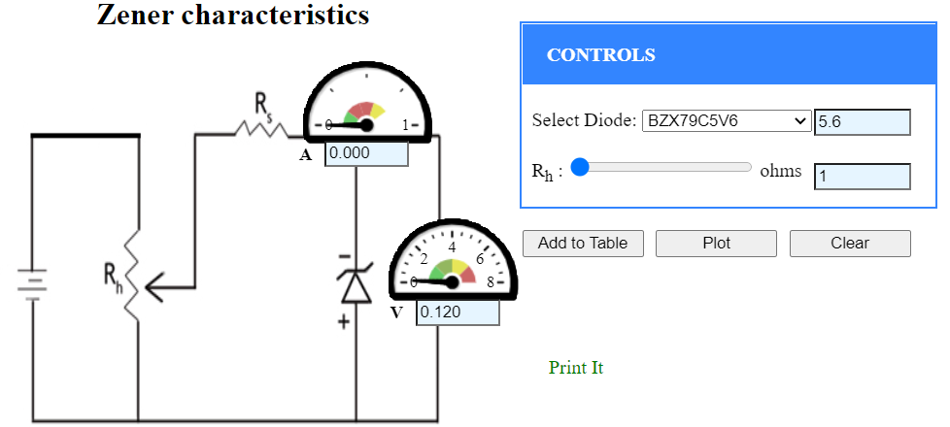

|  |  |  |
| --- | --- | --- |
| Sr. No. | Zener Voltage (V) | Current (mAmp) |
| 1 | 0.720 | 0.000 |
| 2 | 1.310 | 0.000 |
| 3 | 1.877 | 0.000 |
| 4 | 2.422 | 0.000 |
| 5 | 2.953 | 0.001 |
| 6 | 3.475 | 0.001 |

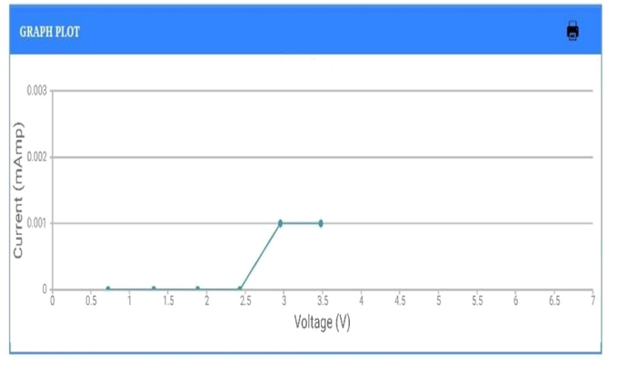

**CALCULATIONS**: -

Dynamic Resistance:

**RESULTS**: -

1. Plot V-I characteristics of Zener diode on a suitable graph paper.

2. The dynamic resistance of diode

**PRECAUTIONS:** -

1. Make the connection properly.
2. Don’t exceed the maximum specified value of current for the given diode.

**REPORT**: -

1. Plot V-I characteristics of the given Zener diode.
2. How breakdown voltage depends on temperature? Explain.
3. What is difference between p-n junction diode and Zener diode fabrication?

SHRI G.S. INSTITUTE OF TECHNOLOGY AND SCIENCE, INDORE-3

DEPARTMENT OF ELETRONICS & COMMUNICATION

ELECTRONICS DEVICES

Session: __________ Date_____________

Roll no. : _____________ Name of student______________

Remarks: _____________

**Signature of professor**

**EXPERIMENT-06**

**AIM**: - To construct a zener diode voltage regulator and measure its line and load regulation.

**OBJECT**: To measure load current and load voltage for both line and load regulator

**APPARATUS REQUIRED**:

1. Experimental board.
2. Components: Zener diode, 1kΩ resistor, 22kΩ potentiometer.
3. Variable DC power supply (0 – 20V)
4. DC ammeter (2)
5. 0 -10 mA (b) 0 - 50 mA
6. Electronic multimeter
7. Connecting probes.

**CIRCUIT DIAGRAM**: -

|  |  |
| --- | --- |
|  | |
| (a) Line regulation | (b) ) Load regulation |
| Fig. 1 Experimental set up for Voltage regulation | |

**THEORY**:

The DC power supplier needed for electronic circuits are generally obtained by rectifying the available a. c. power supply using vacuum or semiconductor diodes. The usual trouble with these rectifiers is the variation to the output voltage with the change in the load current as well as the change with the fluctuations in- the supply voltage. This is undesirable in electronics at constant irrespective of a. c. supply voltage. A regulated power supply will deliver power to electronic circuits at constant voltage irrespective of AC supply voltage fluctuation and load current variation.

**Zener diode as regulator**: -

The simplest regulator consists merely of resistor Rs connected in series with the input voltage and a Zener diode connected in parallel with the load as shown in figure. The series resistance limits the Zener current from exceeding its rated maximum.

**(a) Line regulation**:-

Consider the circuit as shown in Fig. 1 (a). As long as the voltage across is less than the Zener-breakdown voltage the Zener diode doesn’t conduct and the current voltage with the change in line voltage V. When the voltage across becomes greater the Zener breakdown voltage, the Zener diode operates in breakdown region. Now if input voltage increase, the Zener diode passes a large current. So that extra voltage is dropped across. Conversely, if fall, the current Iz also falls and voltage across Rs reduced, keeping VL constant.

**(b) Load regulation**:-

Consider Fig. 1 (b) at the junction of Zener diode and load resistance the current splits as

When Zener diode operates in breakdown region the voltage across it remains fairly constant even through the current flowing through it vary considerably. If load current increases (because of fluctuation in), the current through the zener diode falls by the same percentage in order to maintain constant current. This keeps voltage drop constant across , hence output voltage remains constant. On other hand, the load current should decrease. The zener diode passes an extra current such that the current is constant. The output voltage is thus stabilized.

**PROCEDURE**:-

1. Connect the circuit as shown in figure. Keep = constant. Vary the input voltageslowly and record the corresponding reading of, and. This is line regulation.
2. Take sufficient readings to plot graph between load current and load voltage.
3. Now keep constant such that zener breakdown has occurred. Now start varing the load resistance from 1k onwards and record the correspond readings of, and. Plot a graph between load current and load voltage for load regulation.

**OBSERVATIONS**: -

|  |  |
| --- | --- |
| (a) Line regulation | (b) Load regulation |
| 𝜴 |  |
|  |  |
| Range of ammeter for = | |
| Range of ammeter for = | |
| Least count of ammeter for = | |
| Least count of ammeter for = | |

**OBSERVATION TABLE**: -

|  |  |  |  |  |
| --- | --- | --- | --- | --- |
| S No. | Line regulation | | Load regulation | |
| R= | | Vi = | |
| Load voltage | Load current | Load voltage | Load current |
| 1 |  |  |  |  |
| 2 |  |  |  |  |
| 3 |  |  |  |  |
| 4 |  |  |  |  |
| 5 |  |  |  |  |
| 6 |  |  |  |  |
| 7 |  |  |  |  |
| 8 |  |  |  |  |
| 9 |  |  |  |  |
| 10 |  |  |  |  |
| 11 |  |  |  |  |
| 12 |  |  |  |  |
| 13 |  |  |  |  |
| 14 |  |  |  |  |
| 15 |  |  |  |  |

**RESULT**: -

A regulation characteristic of Zener-diode is shown in the graph paper.

**REPORT**: -

1. Plot the regulation characteristics cases.
2. What conclusion you draw by doing this experiment.

SHRI G.S. INSTITUTE OF TECHNOLOGY AND SCIENCE, INDORE-3

DEPARTMENT OF ELETRONICS & COMMUNICATION

ELECTRONICS DEVICES

Session: __________ Date_____________

Roll no. : _____________ Name of student______________

Remarks: _____________

**Signature of professor**

**EXPERIMENT-07**

**AIM**: - Observation and evaluation of parameters and waveform of different types of rectifiers.

**OBJECT**:

1. To plot input and output waveform as seen on CRO.
2. To measure ripple factor.

**APPARATUS REQUIRED**:

1. Experimental board
2. Components: Rectifier diodes, resistor.
3. CRO with probe
4. Multimeter
5. Connecting wires

**CIRCUIT DIAGRAM: -**

|  |  |
| --- | --- |
|  |  |
| Fig. 1 Half wave rectifier circuit | Fig. 2 Full wave Centre- trapped rectifier |
|  | |
| Fig. 3 Full wave Bridge rectifier circuit | |

**THEORY**: - Rectifiers are used to convert ac signal into dc signal. In electronics the diode are used to rectify the signal. Diode provides high resistance (stop signal) when it is reverse bias and provides low resistance (allow the signal) when it is forward bias. In this manner diode is used to rectify a. c. signal. The signal at the output of the rectifier is not pure D.C. it still contains some ripple of A.C. signal.

1. Half wave rectifier.
2. Full wave rectifier
3. Centre- trapped
4. Bridge Rectifier

**(a) Half wave rectifier**: -Refer Fig. 1.

In half wave rectifier there is one diode, a transformer and a load resister. In this we get the output voltage across the load for only positive half cycle. During negative half cycle the voltage across the load resistance is zero. Thus, a pure ac is converted into a unidirectional signal.

It can be shown that

where is output dc voltage

= peak ac voltage at input of rectifier circuit

1. Ripple factor = 

For half wave

and

Hence, Ripple factor =

= 1.21 (theoretical)

**(b) Full wave rectifier**: - Refer Fig. 2.

In full wave rectifier there are two diodes, a transformer and a load resister. The transformer has a centre-tap in the secondary winding. It provide out of full voltage to the two diodes. During positive half cycle diode is reverse biased and it doesn’t conduct but diode is forward biased and it conducts. Thus, it develops voltage across load during negative half-cycle diode conducts and allows current pass through. The dc voltage obtained at output is given as

Where peak values of ac voltage between the centre -tap point and one of the diode.

Ripple factor = 

Ripple factor

= 0.482

Where,

and

**(c) Bridge rectifier**: -Refer Fig. 3.

In bridge rectifier circuit there are four diodes, a transformer and load resister. During positive half cycle diode and conducts and current passes through. During the other half of input signal, diode and conducts. Thus, we get unidirectional signal for both half-cycle of input ac.

Output dc voltage

Ripple factor = 0.482

**PROCEDURE**:

1. Connect primary side of transformer to ac mains.
2. Check CRO probes by displaying in built square wave.
3. Connect the CRO probes to the transformer, secondary. Note down the reading and draw i/p waveform.
4. Make connections to the half wave rectifier circuit and seen the output of it across the load resister on CRO. Draw the output waveform.
5. Now use a multimeter to measure ac voltage at secondary of transformer. These gives RMS values multiply it by to get peak value. Calculate theoretical value of dc.
6. Compare this with practical value.
7. Also measure ac and dc voltage at output points.
8. Using measured value of dc and ac output voltages, calculate ripple factor. It should be about 1 - 21.
9. Measure PIV across reverse biased diode.
10. Repeat above procedure for full wave, Centre-tapped and bridge rectifiers.

**OBSERVATIONS**: -

1. Code number of diode =
2. Information from data book
3. Maximum forward dc current =
4. Peak inverse voltage (PIV) =
5. Measurement of different voltage.

|  |  |  |  |
| --- | --- | --- | --- |
| Circuit | AC voltage at input | AC voltage at output | DC voltage at output |
| (a) Half wave rectifier |  |  |  |
| (b) Full wave centre rapped |  |  |  |
| (c) Bridge rectifier |  |  |  |

1. Verification of theoretical formula.

|  |  |  |  |
| --- | --- | --- | --- |
| Circuit | Quantity | Theoretical value | Practical value |
| (a) Half wave rectifier | Output voltage |  |  |
| Ripple factor |  |  |
| (b) Full wave rectifier | Output voltage |  |  |
| Ripple factor |  |  |
| (c) Bridge rectifier | Output voltage |  |  |
| Ripple factor |  |  |

**RESULT**: -

1. Input and output waveforms for each rectifier as seen from CRO and drawn on graph - paper.
2. The output dc voltage is little less than theoretical value.
3. There is a little difference between theoretical and practical value of ripple factor.

**REPORT**: -

1. Draw the waveform for each rectifier as seen on CRO.
2. Compare various rectifier circuits.

SHRI G.S. INSTITUTE OF TECHNOLOGY AND SCIENCE, INDORE-3

DEPARTMENT OF ELETRONICS & COMMUNICATION

ELECTRONICS DEVICES

Session: __________ Date_____________

Roll no. : _____________ Name of student______________

Remarks: _____________

**Signature of professor**

**EXPERIMENT-08**

**AIM**: - To observe the waveform of half wave & full wave rectifiers with different types of filters.

**APPARATUS REQUIRED**:

1. Experimental board
2. Inductors, capacitors and resistors
3. Multimeter
4. CRO with probe
5. Connecting wires

**CIRCUIT DIAGRAM**: -

|  |  |
| --- | --- |
|  |  |
| Inductor filter | Capacitor Filter |
|  |  |
|  |  |
| LC filter | filter |

**THEORY**: -

The output of a half wave or full wave rectifier contains an appreciable amount of ac voltage in addition to dc Voltage.

The ac variations can be filtered out or smoothed out from the rectified voltage. This is done by filter circuits.

**1.** **Shunt Capacitor filter**:-

In a shunt capacitor filter, we put a high-value capacitor in shunt with the load. The capacitor offers a low impedance path to the ac components of current. Most of the ac current passes through the shunt capacitor. All dc current passes through load resistor. The capacitor tries to maintain the output voltage at. This is shown below full half rectifier.

|  |
| --- |
|  |

Ripple Factor



Capacitor filter is good for light loads i.e. for large value of C should also high series.

**2.** **Indicator filter**:-

In series inductor filter an inductor is used in series with the load. The inductor offers high impedance to ac variations of current and low impedance to dc as



As a result, the output across the load has very low ac content. The output becomes a much better dc.

Ripple factor

The inductor filter is more effective only for heavy load currents i.e. when is small. The ac component will be reduced if we use inductor of large value.

1. **LC filter**:-

The LC Filter also called as choice input filter has combined effect of C and L filter. Since in inductor filter, the ripple factor is directly proportional to the load resistance 8 in capacitor filter, it is varying inversely with load resistance. Hence if we combine both, the ripple factor will become almost independent of.

Ripple factor

**4.** **-filter**: -

A -filter utilizes the filter properties of both the inductor and capacitor. It uses two capacitors and one inductor. With this type of filter, the rectified output becomes almost free from ac.

**PROCEDURE**:-

1. Connect the circuit as shown in Fig 1 observe and plot the input and output waveforms.
2. Measure output ac and dc Voltages. Calculate ripple factor for shunt filter. Also calculate the theoretical value using the given forms.
3. Repeat above procedure for L, LC and π filter.

**OBSERVATIONS TABLE: -**

|  |  |  |  |  |  |
| --- | --- | --- | --- | --- | --- |
| For Full wave rectifier | | | | | |
| S. No. | Filter Type | Vac Volts. | Vdc Volts | Ripple Factor Theoretical | Ripple Factor  Practical |
| 1 | Shunt C-filter |  |  |  |  |
| 2 | Series L-filter |  |  |  |  |
| 3 | LC- filter |  |  |  |  |
| 4 | filter |  |  |  |  |

**RESULT**: -

1. With the use of filters in rectifier circuit, ripple voltages are very much reduced.
2. With -filter output voltage is almost a pure dc.

**REPORT**: -

1. Plot various waveforms for each filter circuit on graph paper.
2. Explain why a series-inductor filter cannot be used with a half-wave rectifier.
3. What is a bleeder resistor?

SHRI G.S. INSTITUTE OF TECHNOLOGY AND SCIENCE, INDORE-3

DEPARTMENT OF ELETRONICS & COMMUNICATION

ELECTRONICS DEVICES

Session: __________ Date_____________

Roll no. : _____________ Name of student______________

Remarks: _____________

**Signature of Professor**

**EXPERIMENT-09**

**AIM**: - Testing of transistor.

**OBJECTIVE**:-

1. To test a Transistor whether it is PNP or NPN.
2. To identify the lead configuration.

**APPARATUS REQUIRED**: -

1. Transistor to be tested.

2. Ohmmeter

3. Connectors

**CIRCUIT DIAGRAM**: -

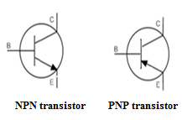

**THEORY**: - Transistor of various types and rating are available depending upon the desired performance of a particular electronic circuit. A designer chooses the transistors according to the availability, cost and the suit-ability of the specifications.

Different manufacturers adopt different methods of manufacturing the transistors. Many a times the connections for the different leads (emitter, base and connector) are different for different types of transistors. It is advisable to refer the manual or technical data for knowing the various data of a given transistor. When the technical data is not available or the number marked on the transistor is not legible, by performing some simple test we can find out.

i. Whether transistor is PNP or NPN type.

ii. The lead configurations i.e. to recognize base, emitter and collector terminals.

When base collector or base emitter junction is forward biased, the do resistance is low. The resistance is high when junctions are reverse-biased. The dc resistance between emitter and collector is high irrespective of the polarity of the applied voltage in both the directions.

These facts help us to find out whether a transistor is PNP or NPN type and in recognizing the base lead. Once the base has been recognized it remains to identify the emitter and collector terminals. In normal application, the base- emitter junction is forward biased whereas the collector is reverse - biased. In order that large fraction of emitter current is collected by the collector, the base emitter junction is made up of smaller cross - section than that of collector junction. Also the dropping density of emitter region is made highest.

**PROCEDURE**:-

1. Name the terminals of transistor to be tested as x, y and z.
2. Fit it in circuit board and using range of Ohmmeter measure the resistance between x, y, z.
3. Enter the readings in observation table.
4. If resistance beta XY and X2 is either low or high, then X terminal is base and if resistance is low transistor is NPN and it is high transistor is PNP.
5. Now to identity collector and emitter terminal, place the transistor in slot provided for transistor in a digital multimeter of transistor is NPN then place it in NPN slot and if it is PNP then place it into PNP slot then measure the value of transistor. If value lies in range (100-350) then terminals connected are true otherwise we have connected emitter into collector & collector into emitter.

**OBSERVATION TABLE**:

|  |  |  |  |
| --- | --- | --- | --- |
| Transistor No | Resistance between terminal | Transistor is | The base lead location is |
|  |  |  |  |
|  |  |  |  |

**RESULT**:

The NPN & PNP transistors are identified.

**REPORT**: -

1. What happens when emitter collector terminals are interchange?

SHRI G.S. INSTITUTE OF TECHNOLOGY AND SCIENCE, INDORE-3

DEPARTMENT OF ELETRONICS & COMMUNICATION

ELECTRONICS DEVICES

Session: __________ Date_____________

Roll no. : _____________ Name of student______________

Remarks: _____________

**Signature of Professor**

**EXPERIMENT-10**

**AIM**: - Study of transistor’s characteristics in CE-configuration. Measure and note input and output V-I.

**OBJECT**:-

1. To characteristics in common emitter configuration.
2. To calculate the parameters of BJT using graphical technique.

**APPARATUS REQUIRED**:

1. Experimental board

2. Variable DC power supply

2. DC ammeter (0-10 mA) - 1 No.

3. DC ammeter (0-500 μA) - 1 No.

4. Voltmeters - 2 No.

**CIRCUIT DIAGRAM**: -

|  |
| --- |
|  |
| Fig 1 Experimental setup for CE-configuration |

**THEORY**: - In CE- configuration, the emitter terminal is common to input and output.

The input characteristics are plotted as the variation (base current) as a function of variation (base to emitter voltage) with (collector to emitter voltage) being kept constant.

The output V-I characteristic are plotted as the variation in (Collector current) as a function of variation in (collector to emitter voltage) with kept constant.

The transfer characteristic is plotted as the variation in (Collector current) as function of variation in (base to emitter voltage) with kept constant.

The common emitter BJT parameters are defined as below and may be calculated from their input and output V-I characteristics curve.

|  |  |  |
| --- | --- | --- |
| Transistor input resistance () | = | (for constant) |
| Transistor current gain () | = | (for constant) |
| Transistor output conductance () | = | (for constant) |
| Transistor reverse voltage gain () | = | (for constant) |

**PROCEDURE**:-

1. **Input characteristics:-**
2. Set collector emitter voltage to 0 volt, and adjust base current to 0, 10, 20, 30, 40, 50 and 500 micro amps, 1mA respectively and note corresponding base – emitter Voltage. Enter the readings in observation table 1.
3. Repeat the same for = 1 V, +2V, +3V, +4V and 5 Volts, 6V, 7V, 8V respectively.
4. **Output characteristics:-**
5. Keep = 0 and vary in steps 0, 0.1, 0.2, 0.3, 0.4, 0.5, 1, 1.5, 2, 2.5 volts in succession and note down corresponding collector current in observation table 2.
6. Repeat the same for = 200, 400, 600, 800 micro amps, 500 mA, 1mA. Note when is varied may change. Every time see that remains same throughout the set of particular readings.
7. **Transfer Characteristics:-**
8. Keep collector emitter voltage to 0 volt. And adjust base emitter voltage to 0, 0.1, 02, 0.3, 0.4, 0.5, 0.6, 0.7, 0.8, 0.9 and 1 volts in succession and note corresponding collector emitter. Enter the readings in observation table 3.
9. Trans-conductance () = (for constant )
10. In the output characteristics the value of for = 0, = and if is known, which is reverse saturation current for reverse bias collector emitter junction.

**OBSERVATION TABLE**:-

1. **Input characteristics** :-

|  |  |  |  |  |  |  |
| --- | --- | --- | --- | --- | --- | --- |
| S. No. | in mA | in volts | | | | |
| = 0V | = | = | = | = |
| 1.  2.  3.  4.  5.  6.  7.  8.  9.  10.  11. | 0  100  200  300  400  500  600  700  800  900  1000 |  |  |  |  |  |

1. **Output characteristics :-**

|  |  |  |  |  |  |  |
| --- | --- | --- | --- | --- | --- | --- |
| S. No. | in volts | in µ / mA | | | | |
| = 0 µA | = | = | = |  |
| 1 |  |  |  |  |  |  |
| 2 |  |  |  |  |  |  |
| 3 |  |  |  |  |  |  |
| 4 |  |  |  |  |  |  |
| 5 |  |  |  |  |  |  |
| 6 |  |  |  |  |  |  |
| 7 |  |  |  |  |  |  |
| 8 |  |  |  |  |  |  |
| 9 |  |  |  |  |  |  |
| 10 |  |  |  |  |  |  |
| 11 |  |  |  |  |  |  |
| 12 |  |  |  |  |  |  |
| 13 |  |  |  |  |  |  |
| 14 |  |  |  |  |  |  |
| 15 |  |  |  |  |  |  |

1. **Transfer characteristics :-**

|  |  |  |  |  |  |  |
| --- | --- | --- | --- | --- | --- | --- |
| S. No. | in volts | in µ / mA | | | | |
| = 0V | = 1V | = 2V | = 3V | = 4V |
| 1.  2.  3.  4.  5.  6.  7.  8.  9.  10. |  |  |  |  |  |  |

**PRECAUTION**:-

1. Initially voltage source should be adjusted to zero.
2. Collector emitter voltage () should not exceed +12 V.
3. Collector current should not exceed 100 mA.
4. Base current should not exceed 1 mA.

**RESULTS**:-

The value of parameters of BJT are-

1. = ______
2. = ______
3. = ______
4. = ______
5. = ______
6. = ______

**REPORT**:-

1. Plot an appropriate graph paper the input and output characteristics curves.
2. Calculate by graphical technique the value of BJT parameters.
3. Calculate the value of from the reading of for.
4. Explain early effect.

SHRI G.S. INSTITUTE OF TECHNOLOGY AND SCIENCE, INDORE-3

DEPARTMENT OF ELETRONICS & COMMUNICATION

ELECTRONICS DEVICES

Session: __________ Date_____________

Roll no. : _____________ Name of student______________

Remarks: _____________

**Signature of Professor**

**EXPERIMENT-11**

**AIM**: - Observe the BJT characteristics in CB configuration.

**OBJECT**:-

1. To measure and plot input and output V- I characteristics of CB – configuration.
2. To calculate it various parameters using graphical technique.

**APPARATUS REQUIRED**:

1. Experimental Board.

2. Variable DC power supply (0-30V) - No. 2

3. DC ammeter (0-200 mA) - No. 2

4. Voltmeters (0-20 V) - N0. 2

5. Connecting probes.

**CIRCUIT DIAGRAM**:-

|  |
| --- |
|  |
| Fig 1 Experimental setup for CB-configuration |

**THEORY**: -

In Common – base configuration, base terminal is common to both input and output. The input characteristics are plotted as the variation of (emitter current) as a function of variation (base to emitter voltage) with (collector to base voltage) being kept constant.

The output characteristics are plotted as the variation in (collector current) as a function of variation in (collector to base voltage) with being kept constant.

The transfer characteristics are plotted as the variation in (collector current) as a function of variation in with kept constant.

The common base BJT parameters are defined as:

|  |  |  |
| --- | --- | --- |
| Transistor input resistance () | = | (for constant) |
| Transistor current gain () | = | (for constant) |
| Transistor output conductance () | = | (for constant) |
| Transistor reverse voltage gain () | = | (for constant) |

In the output characteristics for = 0 is equal to and hence if is known, Ico for BJT can be found out.

Ico = reverse saturation current of the reverse – bias collector to base junction.

The transfer characteristics give BJT trans-conductance.

gm = (for Vcb constant)

**PROCEDURE**:-

1. **Input characteristics** :-
2. Set collector base emitter voltage Vcb to 0 volts and adjust emitter current Ie to 0, 10, 20, 30, 40, 50 microamp, 1mA respectively and note corresponding emitter base voltage Veb.. Enter the readings in observation table. ( No.1)
3. Repeat the same for Vcb = +1V, +2V, +3V, + 4V, +5V, +6V, +7V and +8V respectively.

*Note:-Every time Ie is changed, care must be taken to see that Vcb is kept constant.*

1. **Output characteristics** :-
2. Keep Ie = 0 and vary Vcb in steps and note down corresponding collector current Ic (mA) in observation table. (No. 2)
3. Repeat the same for Ie = 5, 10, 20 mA.

*Note: - When Veb is change, Ic changes. Every time see that Ie remains constant throughout the set of particular readings.*

1. **Transfer characteristics** :-
2. Keep collector emitter voltage to 0 volt. And adjust base to emitter voltage Vbe to 0, 0.1, 0.2 0.3, 0.4, 0.5 0.6, 0.7, 0.8, 0.9 and 1 volts.

*Note: - corresponding collector current ( Ic). Enter the readings in observation table 3.*

**OBSERVATION TABLE**:-

1. **Input characteristics** :-

|  |  |  |  |  |  |  |  |
| --- | --- | --- | --- | --- | --- | --- | --- |
| S. No. | Ie in mA | Vebin volts | | | | | |
| VCB = 0V | VCB = 1V | VCB = 2V | VCB = 3V | VCB = 4V | VCB = 5V | |
| 1.  2.  3.  4.  5.  6.  7.  8.  9.  10.  11. | 0  100  200  300  400  500  600  700  800  900  1000 |  |  |  |  |  |  | |

1. **Output characteristics:-**

|  |  |  |  |  |  |  |  |
| --- | --- | --- | --- | --- | --- | --- | --- |
| S. No. | VCB in volts | Icin µ / mA | | | | | |
| Ie= 0 µA | Ie= 100µA | Ie= 200µA | Ie= 300µA | Ie= 400µA | Ie= 500µA |
| 1.  2.  3.  4.  5.  6.  7.  8.  9.  10.  11. | 0  +1  +2  +3  +4  +5  +6  +7  +8  +9  +10 |  |  |  |  |  |  |

1. **Transfer characteristics :-**

|  |  |  |  |  |  |  |  |
| --- | --- | --- | --- | --- | --- | --- | --- |
| S. No. | VEB in volts | Icin mA | | | | | |
| VCB = 0V | VCB= 1V | VCB = 2V | VCB = 3V | VCB = 4V | VCB = 5V |
| 1.  2.  3.  4.  5.  6.  7.  8.  9.  10.  11. |  |  |  |  |  |  |  |

**PRECAUTION**:-

1. Initially voltage source should be adjusted to zero

**RESULTS**:-

The value of parameters of BJT are-

1. = ______
2. = ______
3. = ______
4. = ______
5. = ______
6. = ______

**REPORT**:-

1. Plot the input, output and transfer characteristics on a graph paper.
2. Calculate values of BJT parameters using graphical technique.
3. Calculate the value of Ico from the reading of Ic for Ie = 0.
4. Derive relation between α& β.

SHRI G.S. INSTITUTE OF TECHNOLOGY AND SCIENCE, INDORE-3

DEPARTMENT OF ELETRONICS & COMMUNICATION

ELECTRONICS DEVICES

Session: __________ Date_____________

Roll no. : _____________ Name of student______________

Remarks: _____________

**Signature of Professor**

**EXPERIMENT-12**

**AIM**: - Observe the characteristics of BJT in CC (Common collector) configuration.

**OBJECT**:-

1. To plot input / output V- I characteristics and transfer characteristics in CC – configuration.
2. To calculate it various parameters.

**APPARATUS REQUIRED**:

1. Experimental Board.

2. Variable DC power supply (0-20V) - No. 1

3. DC ammeter (0-200 mA) - No. 2

4. Voltmeters (0-20 V) - N0. 2

5. Connecting probes.

**CIRCUIT DIAGRAM**:-

|  |
| --- |
| http://pages.physics.cornell.edu/p510/w/images/p510/6/6f/EmitterFollower.png |
| Fig 1 Experimental setup for CC-configuration |

**THEORY**: - In CC configuration, collector is common to both input and output.

The input characteristics are plotted as the variation of Ib( base current ) as a function of variation in Vbc ( base to collector ) with Vce being kept constant.

The output V- I characteristics are plotted as the variation in Ie( emitter current ) as a function of variation in Vec ( emitter to collector voltage ), with Ib being kept constant.

The transfer characteristics are plotted as the variation in Ie ( emitter current ) as a function of variation in Vbe ( base to collector voltage ) with Vec kept constant.

The common base BJT parameters are defined as below and may be calculated from input and output V-I characteristics curves.

1. Transistor input resistance( hie ) = (for Vec constant)
2. Transistor current gain( hfe ) = (for Vec constant)
3. Transistor output conductance ( hoc) = (for Ib constant)
4. Transistor reverse voltage gain( hre) = (for Ib constant)

**PROCEDURE**:-

1. **Input characteristics** :-
2. Set emitter to collector voltage Vec to 0 volts and adjust base current Ib to 100, 200, 300, up to I mA respectively and note corresponding base emitter voltage Vbe. Enter the readings in observation table. ( No. 1 )
3. Repeat the same for Vec= +2V, + 4V, +6V, +8V respectively.

Note:-Every time Ib is changed, care must be taken to see that Vec is kept constant for a particular set of readings.

1. **Output characteristics**:-
2. Keep Ib = 0 and vary Vec in steps 0V, 1V, 2V, 3V up to 8V respectively and note down corresponding emitter current Ie. .
3. Repeat the same for Ib = 200, 400, 500 up to 1 mA.

Note: - When Vecis varied, Ib changes. Every time see that Ib remains the same throughout the set of particular readings.

1. **Transfer characteristics**:-
2. Keep emitter to collector voltageVec to 0 volt. And adjust base to collector voltage to 0, 1V, 2V, 3V, etc. and note corresponding emitter current ( Ie ).
3. Enter the readings in observation table 3.

**OBSERVATION TABLE**:-

1. **Input characteristics** :-

|  |  |  |  |  |  |
| --- | --- | --- | --- | --- | --- |
| S. No. | Ib in mA | Vbcin volts | | | |
| VCB = 0V | VCB = 0V | VCB = 0V | VCB = 0V |
| 1.  2.  3.  4.  5.  6.  7.  8.  9.  10.  11. | 0  100  200  300  400  500  600  700  800  900  1000 |  |  |  |  |

1. **Output characteristics :-**

|  |  |  |  |  |  |
| --- | --- | --- | --- | --- | --- |
| S. No. | VEC in volts | Iein µ / mA | | | |
| Ib= 0 µA | Ib= 200 µA | Ib= 400 µA | Ib= 600 µA |
| 1.  2.  3.  4.  5.  6.  7.  8.  9.  10.  11. | 0  +1  +2  +3  +4  +5  +6  +7  +8  +9  +10 |  |  |  |  |

1. **Transfer characteristics :-**

|  |  |  |  |  |  |
| --- | --- | --- | --- | --- | --- |
| S. No. | Vbc in volts | Iein mA | | | |
| Vec= 0V | Vec= 3V | Vec= 4V | Vec= 6V |
| 1.  2.  3.  4.  5.  6.  7.  8.  9.  10.  11. |  |  |  |  |  |

**RESULTS**:-

The value of parameters of BJT are-

1. = ______
2. = ______
3. = ______
4. = ______
5. = ______
6. = ______

**REPORT:-**

1. Plot the input, output and transfer characteristics on a graph paper.
2. Calculate values of BJT parameters in CC configuration.
3. Calculate the value of for = 0.

SHRI G.S. INSTITUTE OF TECHNOLOGY AND SCIENCE, INDORE-3

DEPARTMENT OF ELETRONICS & COMMUNICATION

ELECTRONICS DEVICES

Session: __________ Date_____________

Roll no. : _____________ Name of student______________

Remarks: _____________

**Signature of Professor**

**EXPERIMENT-13**

**AIM**: Construct the fixed bias circuit with and without emitter resistor.

**OBJECT**:

1. Measure the Q point collector current and collector to emitter voltage with and without emitter resistor RE.
2. Note the variation of the Q point by increasing the temperature of the transistor in fixed bias circuit with and without emitter resistor RE.
3. Note the variation of the Q point by changing the base resistor in bias circuit, when emitter resistor is present and not present.

**APPARATUS REQUIRED**:

1. Experimental board
2. Electronics multimeter
3. DC ammeter
4. Power supply 15V

**CIRCUIT DIAGRAM**:

|  |
| --- |
| http://www.electrical4u.com/images/bjt-biasing-01-09-02-14.gif |
| Fig 1 Experimental setup for fixed bias circuit with and without emitter resistor |

**THEORY**:-

The biasing circuit when the emitter resistor is not present generally referred to as fixed bias circuit (i.e. when in closed position).

In this circuit, the operating point current

≌ is given by

= ≌

…………… (1)

…………… (2)

As the temperature of collector to base junction changes the leakage current increases. Since

The operating point may go into the saturation region. Sometimes, thermal runaway may also take place. When the emitter resistor RE is added in the circuit (i.e. when switch S1 is in the open position) the operating point is given by

Since,

=

and

– ()

If temperature increases, the following sequence of events takes place.

↑ T → → → → ↓

This shows that there is a tendency to make the operating point stable.

**PROCEDURE**:

1. Take the experimental board and identify the resistor. Also find out their values.
2. Apply 15v and close switch S1. Connect milliammeter and voltmeter. Note value of and.
3. Increase the temperature of the transistor (by rubbing your hands together and touching the transistor or by putting a lamp near it) and note the effect on collector current.
4. Now put off the switch S1 so that the emitter resistor comes in circuit. Note new operating point.
5. Now increase the temperature and note the effect on the operating point.
6. Now change the switch S2 in such a way that the base resistor changes with the new value of base resistor, repeat above experiment.

**OBSERVATION**:

When switch S1is closed i.e. is not in the circuit

|  |  |  |  |  |  |  |
| --- | --- | --- | --- | --- | --- | --- |
| S. No. |  |  |  | |  | |
| Theoretical | Practical | Theoretical | Practical |
|  |  |  |  |  |  |  |

**RESULT**:

It is found that the effect of increasing temperature on the collector current, is much reduced when is brought into the circuit.

**REPORT**:

1. Explain why fixed bias circuit is not generally used.
2. Why biasing of transistor is necessary.

SHRI G.S. INSTITUTE OF TECHNOLOGY AND SCIENCE, INDORE-3

DEPARTMENT OF ELETRONICS & COMMUNICATION

ELECTRONICS DEVICES

Session: __________ Date_____________

Roll no. : _____________ Name of student______________

Remarks: _____________

**Signature of Professor**

**EXPERIMENT-14**

**AIM**: Design a Collector to base feedback bias circuit.

**OBJECT**:

1. To measure the Q point collector current and collector to emitter voltage.
2. Note the change in a point when temperature of the transistor changes.
3. Compare with fixed bias circuit.

**APPARATUS REQUIRED**:

1. Experimental board
2. Electronics multimeter
3. DC power supply 15V
4. DC ammeter
5. Connecting probes

**CIRCUIT DIAGRAM**:

|  |
| --- |
|  |
| Fig 1 Experimental setup for Collector to base feedback bias circuit |

**THEORY**: In Collector to base feedback circuit, the operating point is given as

In this circuit, the operating point has a tendency to be stable against temperature variations as shown by following sequence.

**PROCEDURE**:

1. Trace the given bias circuit. Note the value of various resistors in the circuit.
2. Apply, put the switch in x position so that is connected between supply and base terminal. Note Q point collector current Ic and collector to emitter voltage.
3. Increase temperature of transistor by 1 ampere by rubbing hands together and touching the transistor. Note variation in Q point.
4. Now change the switch to y position. So that base resistor gets connected between collector and base. Note the Q point.
5. Repeat step 3 for this circuit.

**OBSERVATION**:

1. For fixed bias circuit

= ______V, = ______V, Ic = ______mA.

At highest temperature, Ic = ______mA.

1. For collector to base feedback circuit

= ______V, = ______V, Ic = ______mA.

At highest temperature, Ic = ______mA.

**RESULT**:

It is observed that the Q point shifts much slowly in collector to base feedback circuit as compared with fixed bias circuit, when temperature is changed.

**REPORT**:

1. Compare collector to base circuit with fixed bias circuit.

SHRI G.S. INSTITUTE OF TECHNOLOGY AND SCIENCE, INDORE-3

DEPARTMENT OF ELETRONICS & COMMUNICATION

ELECTRONICS DEVICES

Session: __________ Date_____________

Roll no. : _____________ Name of student______________

Remarks: _____________

**Signature of Professor**

**EXPERIMENT-15**

**AIM**: Design a Potential-divider biasing circuit.

**OBJECT**:

1. To measure the Q point collector current and collector to emitter voltage.
2. Note the operating point when one of the bias resistor changes.
3. Note the effect of change of temperature on the Q point.

**APPARATUS REQUIRED**:

1. Experimental board
2. DC power supply 15V
3. Electronics multimeter
4. DC ammeter
5. Connecting probes

**CIRCUIT DIAGRAM**:

|  |
| --- |
| https://upload.wikimedia.org/wikipedia/commons/f/f7/Voltage_divider_bias.PNG |
| Fig 1 Experimental setup for Potential-divider bias circuit |

**THEORY**: Potential-divider bias circuit is a widely used biasing circuit in amplifiers. The most significant advantage of this circuit is that the operating point is almost independent of β. The expression for emitter current (which is also equal to collector current) is given by

=

The collector to emitter voltage is given by

– ()

The operating point can be changed by changing one of the resistors of the Potential-divider network. In the experiment, two values of resistor are provided.

**PROCEDURE**:

1. From the given circuit, find out whether transistor is PNP or NPN and note down value of different resistors.
2. Connect the collector supply dc voltage.